
Information & Security lab - 251L
Muhammad Talha
Section

CS.3ndB
Registration NO:
UW-24-CS-BS-101
UNIVERSITY OF WAH(UOW)

DEPARTMENT OF COMPUTER
SCIENCE

COURSE:

SUBMITTED TO:

Ms. Wasifa Kanwal
SUBMITTED BY:

Lab Task # 03
Task # 01
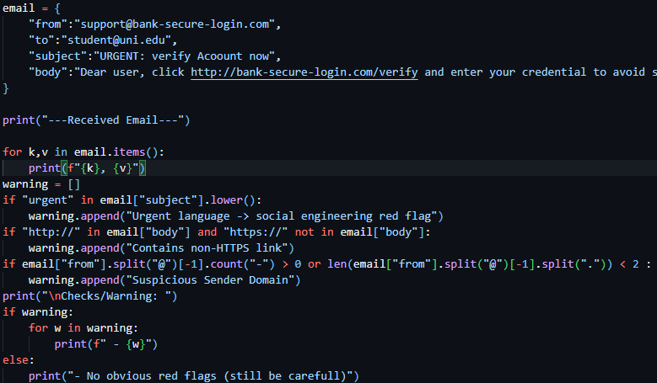
Output
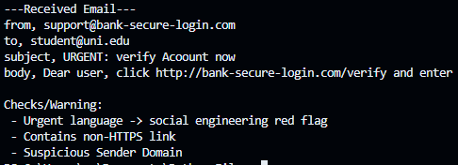
Code
email = {
"from":"support@bank-secure-login.com",
"to":"student@uni.edu",
"subject":"URGENT: verify Acoount now",
"body":"Dear user, click http://bank-secure-login.com/verify and enter your credential to avoid suspension."
}
print("---Received Email---")
for k,v in email.items():
print(f"{k}, {v}")
warning = []
if "urgent" in email["subject"].lower():
warning.append("Urgent language -> social engineering red flag")
if "http://" in email["body"] and "https://" not in email["body"]:
warning.append("Contains non-HTTPS link")
if email["from"].split("@")[-1].count("-") > 0 or len(email["from"].split("@")[-1].split(".")) < 2 :
warning.append("Suspicious Sender Domain")
print("\nChecks/Warning: ")
if warning:
for w in warning:
print(f" - {w}")
else:
print("- No obvious red flags (still be carefull)")

Task # 02
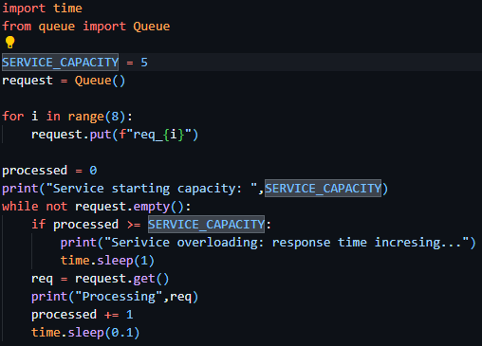
Output
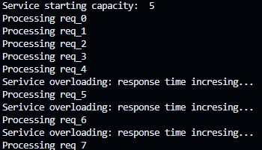
Code

import time
from queue import Queue

SERVICE_CAPACITY = 5
request = Queue()

for i in range(8):
request.put(f"req_{i}")

processed = 0
print("Service starting capacity: ",SERVICE_CAPACITY)
while not request.empty():
if processed >= SERVICE_CAPACITY:
print("Serivice overloading: response time incresing...")
time.sleep(1)
req = request.get()
print("Processing",req)
processed += 1
time.sleep(0.1)

Task # 03
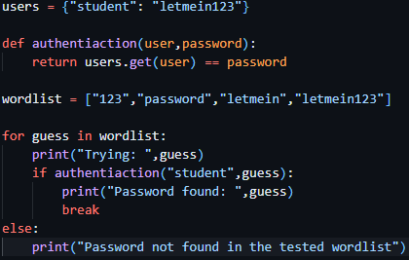
Output
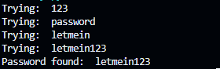
Code
users = {"student": "letmein123"}

def authentiaction(user,password):
return users.get(user) == password

wordlist = ["123","password","letmein","letmein123"]

for guess in wordlist:
print("Trying: ",guess)
if authentiaction("student",guess):
print("Password found: ",guess)
break
else:
print("Password not found in the tested wordlist")

Task # 04
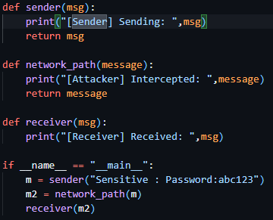
Output
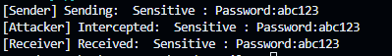
Code
def sender(msg):
print("[Sender] Sending: ",msg)
return msg

def network_path(message):
print("[Attacker] Intercepted: ",message)
return message

def receiver(msg):
print("[Receiver] Received: ",msg)

if __name__ == "__main__":
m = sender("Sensitive : Password:abc123")
m2 = network_path(m)
receiver(m2)

Task # 05
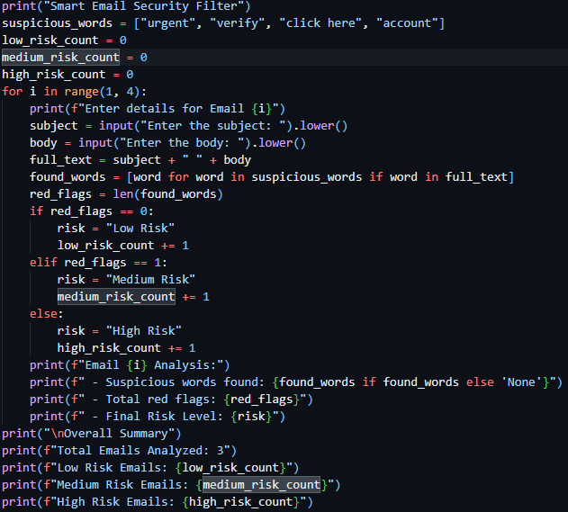

Output
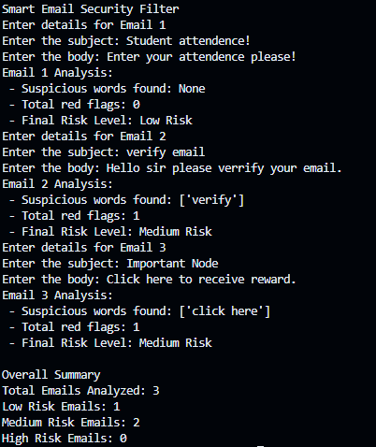
Code
print("Smart Email Security Filter")
suspicious_words = ["urgent", "verify", "click here", "account"]
low_risk_count = 0
medium_risk_count = 0
high_risk_count = 0
for i in range(1, 4):
print(f"Enter details for Email {i}")
subject = input("Enter the subject: ").lower()
body = input("Enter the body: ").lower()
full_text = subject + " " + body
found_words = [word for word in suspicious_words if word in full_text]
red_flags = len(found_words)
if red_flags == 0:
risk = "Low Risk"
low_risk_count += 1
elif red_flags == 1:
risk = "Medium Risk"
medium_risk_count += 1
else:
risk = "High Risk"
high_risk_count += 1
print(f"Email {i} Analysis:")
print(f" - Suspicious words found: {found_words if found_words else 'None'}")
print(f" - Total red flags: {red_flags}")
print(f" - Final Risk Level: {risk}")
print("\nOverall Summary")
print(f"Total Emails Analyzed: 3")
print(f"Low Risk Emails: {low_risk_count}")
print(f"Medium Risk Emails: {medium_risk_count}")
print(f"High Risk Emails: {high_risk_count}")
Task # 06
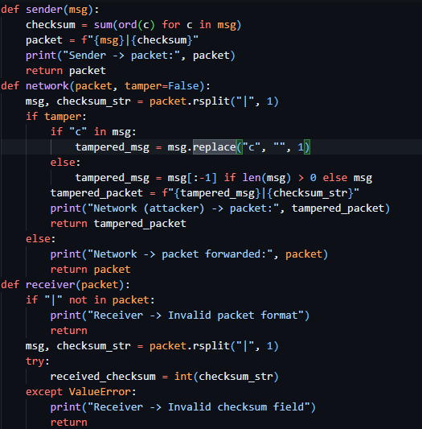
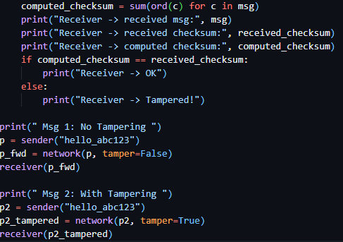
Output
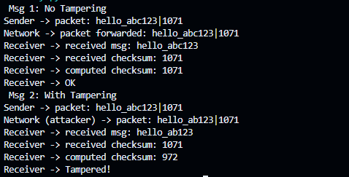
Code
def sender(msg):
checksum = sum(ord(c) for c in msg)
packet = f"{msg}|{checksum}"
print("Sender -> packet:", packet)
return packet
def network(packet, tamper=False):
msg, checksum_str = packet.rsplit("|", 1)
if tamper:
if "c" in msg:
tampered_msg = msg.replace("c", "", 1)
else:
tampered_msg = msg[:-1] if len(msg) > 0 else msg
tampered_packet = f"{tampered_msg}|{checksum_str}"
print("Network (attacker) -> packet:", tampered_packet)
return tampered_packet
else:
print("Network -> packet forwarded:", packet)
return packet
def receiver(packet):
if "|" not in packet:
print("Receiver -> Invalid packet format")
return
msg, checksum_str = packet.rsplit("|", 1)
try:
received_checksum = int(checksum_str)
except ValueError:
print("Receiver -> Invalid checksum field")
return
computed_checksum = sum(ord(c) for c in msg)
print("Receiver -> received msg:", msg)
print("Receiver -> received checksum:", received_checksum)
print("Receiver -> computed checksum:", computed_checksum)
if computed_checksum == received_checksum:
print("Receiver -> OK")
else:
print("Receiver -> Tampered!")

print(" Msg 1: No Tampering ")
p = sender("hello_abc123")
p_fwd = network(p, tamper=False)
receiver(p_fwd)

print(" Msg 2: With Tampering ")
p2 = sender("hello_abc123")
p2_tampered = network(p2, tamper=True)
receiver(p2_tampered)

Task # 06
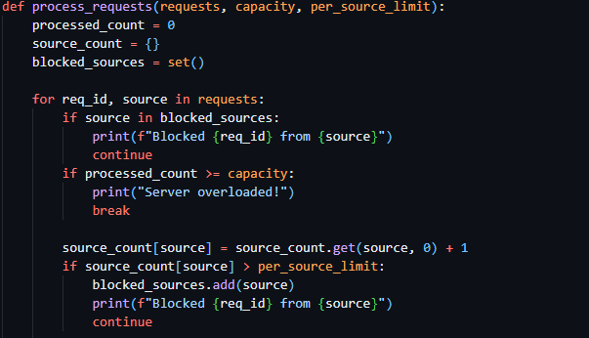
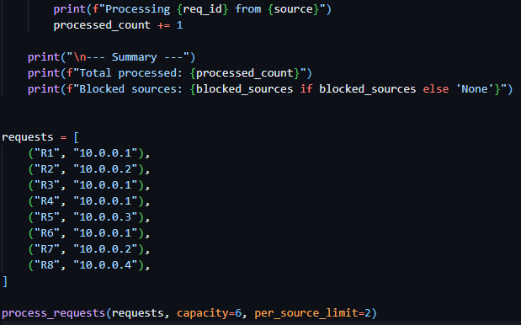
Output
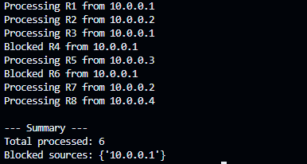
Code
def process_requests(requests, capacity, per_source_limit):
processed_count = 0
source_count = {}
blocked_sources = set()

for req_id, source in requests:
if source in blocked_sources:
print(f"Blocked {req_id} from {source}")
continue
if processed_count >= capacity:
print("Server overloaded!")
break

source_count[source] = source_count.get(source, 0) + 1
if source_count[source] > per_source_limit:
blocked_sources.add(source)
print(f"Blocked {req_id} from {source}")
continue

print(f"Processing {req_id} from {source}")
processed_count += 1

print("\n--- Summary ---")
print(f"Total processed: {processed_count}")
print(f"Blocked sources: {blocked_sources if blocked_sources else 'None'}")

requests = [
("R1", "10.0.0.1"),
("R2", "10.0.0.2"),
("R3", "10.0.0.1"),
("R4", "10.0.0.1"),
("R5", "10.0.0.3"),
("R6", "10.0.0.1"),
("R7", "10.0.0.2"),
("R8", "10.0.0.4"),
]
process_requests(requests, capacity=6, per_source_limit=2)

